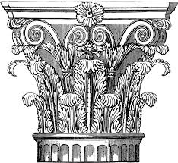
THE PEMBRIDGE ASSOCIATION
…supporting the Pembridge Conservation Area, Kensington, since 1972
www.pembridgeassociation.london | Registered Charity No 267406

GIFT AID DECLARATION

Title: Full Name:

Full home address and postcode:

Email:

Donation: £

Date:

GIFT AID (Please tick the box)
❑ Please treat as Gift Aid donations all qualifying gifts of money to The Pembridge Association made today or in the past four years or in the future.

I am a UK taxpayer and understand that if I pay less Income Tax and/or Capital Gains Tax than the amount of Gift Aid claimed on all my donations in that tax year it is my responsibility to pay any difference.

You can cancel your Gift Aid declaration at any time. Please let us know if you change your name or address or no longer pay sufficient tax on your income and/or capital gains.

If you pay Income Tax at the higher or additional rate and want to receive the additional tax relief due to you, you must include all your Gift Aid donations on your Self-Assessment tax return or ask HM Revenue and Customs to adjust your tax code.

Members making donations or paying subscriptions in the form of Charity Vouchers (Charities Aids Foundation, SmartGiving etc) do not need to complete this declaration as such payments have already received tax relief.

Please send your cheque and completed form to:

The Pembridge Association
7 Viscount Court,
1 Pembridge Villas
London W2 4XA

DAS 27 Aug 17
Ref: AdminPA9995b

